**Angular Web Development – Assignment No. 9**

**Q. No. 1. :**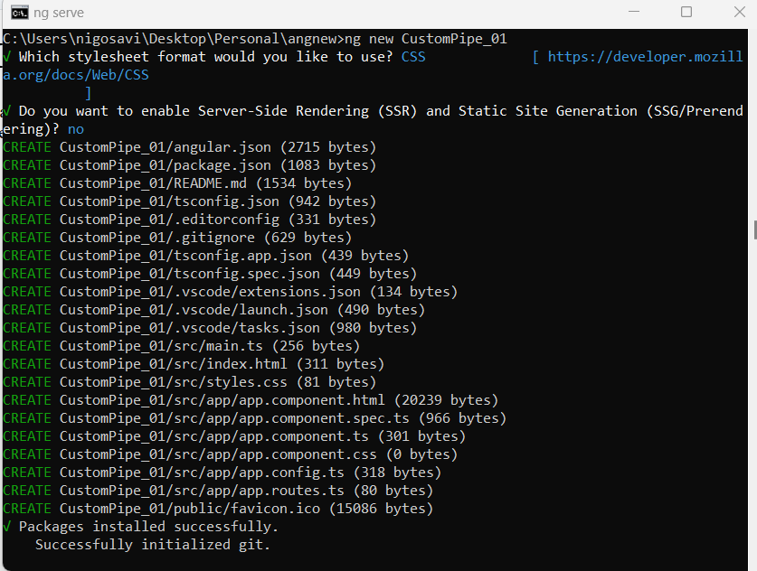

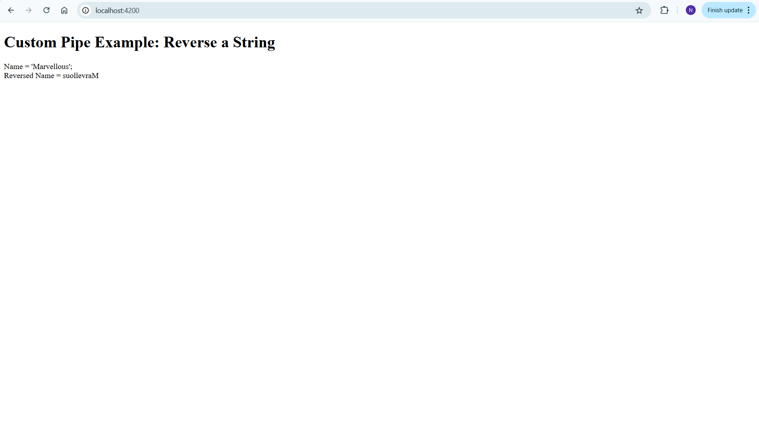

**Q. No. 2:**

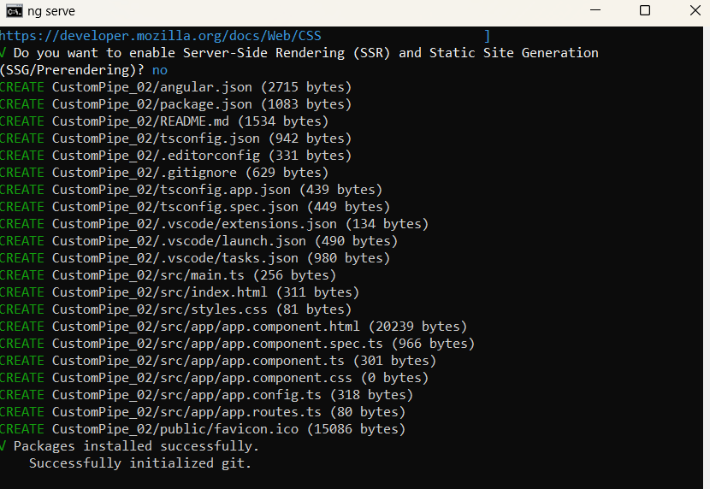

**Q.No. 3:**

